Heuristic Evaluation – Selected Pictures

This document will show a few various images to present the Heuristic Evaluation results. For a real site evaluation, all of the issues could have accompanying images to clearly show what the text might not.

Issue 1: Menubar height is different in IE and Firefox
Issue 2: Webstore does not seem to be a part of the main website.
Issue 9: Not Valid XHTML 1.0
Issue 17: Bread crumbs on shopping pages are useless (they do not function as breadcrumbs).
Issue 23: FAQs are a bit lacking.

Issue 1: Menubar height is different in IE and Firefox

Internet Explorer


Firefox

Issue 2: Webstore does not seem to be a part of the main website.

(This issue has been fixed recently in the site)

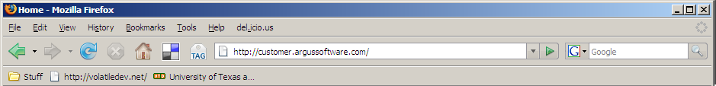
Issue 9: Not Valid XHTML 1.0

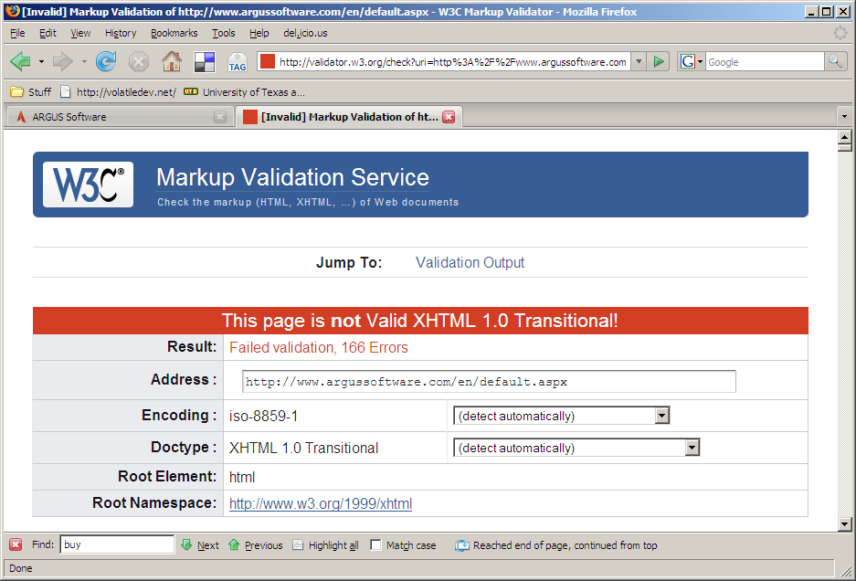
Issue 17: Bread crumbs on shopping pages are useless (they do not function as breadcrumbs).

(This issue has been fixed recently on the site)

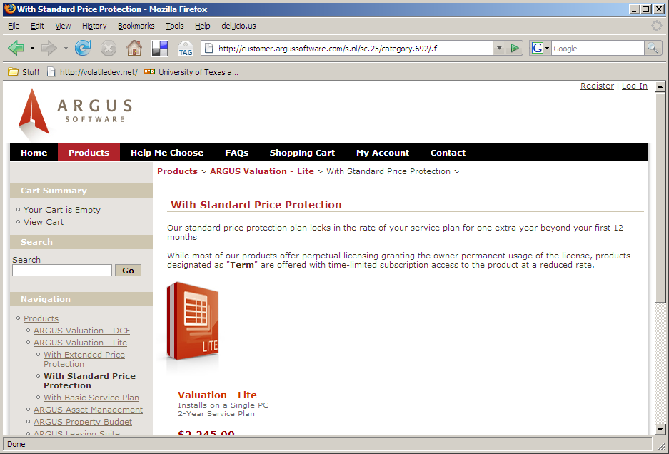
Issue 23: FAQs are a bit lacking.

